DANIEL R SWANDO, P.E., P.M.P. Kissimmee, FL
Dan.Swando@gmail.com (586) 303-5494 (Cell)
www.linkedin.com/in/drswando/

CAREER OVERVIEW
- Professional Engineer (PE) / Project Management Professional (PMP) with proven themed entertainment experience, over fifteen (15) years of automation mechanisms & robotics, facility integration, testing, vendor and project management, and design (20+ yrs with Solidworks CAD).
- Proven history of process improvements, increasing efficiency & safety, specializing in occupant & employee ergonomics.
- Able to work autonomously, coupled with ability to learn & adapt extremely quickly to new tasks or goals.
- Familiar with ISO, ASTM F24, ASME Y14, AWS, MIL, GB standards, Six Sigma and V-Model systems management.
- Actively involved in ASTM F24, MakerFX, Orlando Robotics & Maker Club, DMX Lighting, & Amateur Radio.
- Able to travel as required. Previous Secret security clearance experience.

ENGINEERING EXPERIENCE

Professional Engineer – MARTIN AQUATIC DESIGN, Orlando, FL May 2021 – Present
• Streamlined the design, analysis, calculations and specifications for low and medium voltage power distribution systems and lighting systems
• Integrate PLC with variable-frequency drive motors and controlled sensor arrays for water-filtration
• Perform engineering calculations including pump / compressor selection and foundation structure for themed resorts, water slides, river pools, spas, and interactive water features

• Construct piping and wiring diagrams for design development and construction documents
• Ensure construction documents reflect design & performance requirements conforming to local codes & standards
• Use Revit / AutoCAD to coordinate BIM model with General Contractors (GC) & Landscape Architects
• Review and stamp permit packages & construction documentation

• Work with Universal, Sea World, Merlin and WDI master specifications

Engineering Manager – AIC TECHNOLOGIES, Orlando, FL August 2020 – March 2021
• Lead team of 3 engineers and 5 technicians, and provide leadership, mentorship and coaching
• Supervise and maintain safe operation of laser, CNC, and sheet metal fabrication machinery, and generate production schedule
• Conduct regular performance check-ups and reviews with all subordinates
• Provide regular stakeholder updates through Manager update meetings and Work Management system
• Lead design of prototypical, custom, and standard designs of gas and electric equipment and systems for sale, including custom mobile healthcare / medical facilities, kitchen appliances and associated HVAC & Mechanical, Electrical, and Plumbing (MEP) plans, Installation, Operations, & Maintenance Manuals and other documentation
• Review drawings and installations for fabricated & assembled equipment including Ansul fire safety, HVAC exhaust / makeup venting and apply PE stamps for Authorities Having Jurisdiction (AHJ)
• Establish Scopes of Work and provide stakeholder Communication Plans for new projects
• Execute design reviews with leadership and clients
• Supervise fabrication and testing of designs, including Quality examinations and verifications of gas, plumbing, and fire-safety equipment
• Seek industry certification for assembled gas and electric equipment, including UL, NSF, and Energy Star
• Identify and apply all necessary codes to production of fabricated and assembled equipment, and implement process improvements to comply with such
• Follow all OSHA and internal safety procedures and champion improvement recommendations
• Recommend process improvements to increase efficiency and production schedule
• Championed transition from AutoCAD layouts to Autodesk Inventor, including training and best practices
• Identify potential vendors and work with sourcing / inventory stakeholders for strategic sourcing of components

Project Engineer – UNIVERSAL CREATIVE (ENGINEERING & SAFETY), Orlando, FL February 2017 – August 2020
• Attained Type-1 Ridership approval on Kuka robot mockup, including safety plan, Hazard Analysis, functional and failure-mode testing, SARC, and Core Engineering sign-off
• Established requirements on innovative Ride Vehicles including ASTM F24 Certification, SARC testing, Ergonomic containment testing, ingress/egress & ADA compatibility.
• Standardized and implemented Hazard Analysis and Mitigation training for multidisciplinary teams, including ISO Risk analysis, Failure Mode Effect Analysis (FMEA), and Verification/Validation testing.
• Managed Factory & Site Acceptance Tests (FAT/SAT), including Safety Stop testing, Rockwell Logix 5000 I/O tag data and revision-control
• Performed wind loading calculations in accordance with ASCE-7-16, reviewed 100-yr flood data for worksite
• Corrected structural foundation loads / stiffnesses with architect of record, recovering successful design performance
• Organize and lead internal and external design reviews utilizing Bluebeam reviewing software, and Revit/Navisworks BIM model reviews of MEP, electrical, steam, and plumbing plans
• Utilize Maximo / SAP ERP to investigate maintenance / operations issues on current attractions
• Took initiative to drive ride track delivery & installation and monitor foundation progress
→ Drove on-time installation despite 4-month slip in foundations by working closely with installation vendor & GC
• Renegotiated RFP to achieve BAFO 15% lower than previous bids on scope worth over $1M.
• Facilitate & lead round-table sessions for managing quality & performance of ride-vendors across Universal projects.
• Manage vendor contracts including change orders, approving invoices, collecting vendor deliverables, and validating quality of delivered & installed equipment
• Collaborate with Creative designers to create Scopes of Work (SOW) & established performance requirements based on design intent.
• Present vendor strategy for Animated Figures / Show Action Equipment based on vendor bandwidth & pricing
• Led vendor through redesign of ride vehicle safety restraint / containment testing, and redesign of ADA per Ops needs
• Work with General Contractor (GC) to avoid clearance envelope through creating keep-out inspection gauges
• Review testing protocols, monitored testing, and alerted leadership of critical issues
• Implemented $200,000 cost savings using internal labor over external scenic vendor
• Integrated Resource Loading of Ride Installation into Master Schedule, scheduling around facility & show needs
• Tracked Key Performance Indicators (KPI), risks and managed trends for responsible scopes

Senior Mechanical Engineer - CUBIC SIMULATION SYSTEMS, Orlando, FL November 2014 – December 2016
- Served as “Closer” on multiple projects in need of intensive care, including large proposals & deliverable management, and mentored techs & engineers regarding MIL-Specifications & CAD modeling
• Proposed & implementing new drafting & Solidworks PDM standard procedures & processes to improve design process and reduce drawing time by up to 30%, evaluated by leadership as outstanding

• Analyze training tasks & establish connection with design components to develop WBS / Basis of Estimates
• Managed customer requirement expectations & drove design changes to reduce scope-creep and maintain bottom line on LCS-MBT Trainer.
• Establish derived requirements based on proposal to produce SOWs & manage subcontractors' progress through mock-up, prototype & acceptance testing to ensure final installation reflects requirements
• Led mechanical engineer effort on proposed $55 million re-configurable training simulator to expand future opportunities into new business sectors, evaluated at award with 5 strengths (3 mechanical) with no weaknesses.

• Reviewed Navisworks / Revit BIM Models including structural / MEP (including HVAC / electrical) drawings for new training facilities
• Incorporated 4K HD Display Systems to comply with luminance, optical resolution, EMI, & FOV contract specs

• Performance evaluated by leadership as exceeding requirements overall, in leadership, communication, teamwork, initiative, and productivity

Lead Project Engineer, CAD/PDM Admin - LEAD’AIR INC, Kissimmee, FL March 2012 – November 2014
- Establish organized drawing system, implement manufacturing standards, and lead design team of 3 engineers & 10 CNC operators under Vice President of Engineering for small manufacturer of photogrammetry systems
• “Cradle to grave” project engineer of MIDAS Computer, camera mount, & helicopter installation systems
• Implemented MIL/ASME/ISO Drafting Standards, GD&T, Part numbering, Revision Control & PDM
• Created CNC, sheet metal, and weldment fixtures and shop drawings for high-precision opto-mechanic lenses, LIDAR, and radio communication systems
• Communicate critical installation & integration information to international clients through installation drawings
• Standardized motorized drive systems & created innovative Steadytrack autostabilizing Camera system
• Collaborated with electronics & controls teams to integrate PCBs & touchscreen displays, including faraday shielding to prevent electromagnetic interference (EMI)
• Produce FEA & optimization of vibration and dynamic systems in aircraft at 6G & 9G acceleration utilizing Solidworks Simulation
• Increase quality & efficiency 20% utilizing CAD tools to take machine-engraving time on parts from hours to minutes

Further Engineering experience and portfolio available upon request
EDUCATION/CERTIFICATIONS

2020 – CERTIFIED PROJECT MANAGEMENT PROFESSIONAL (PMP)
2019 – TUV / ISO 13849 Functional Safety certification training #1
2018 – PROFESSIONAL ENGINEERING LICENSE, State of Florida - #85233
2012 – CERTIFIED SOLIDWORKS USER
2002 – NATIONAL EAGLE SCOUT ASSOCIATION

Bachelor of Science KETTERING UNIVERSITY, Flint, MI 2002-2006
• Mechanical Engineering (Biomedical Concentration)
• Specialize in Occupant / Crash Safety (FMVSS, HIC), dynamics (employing Hybrid III testing dummies) & Mechatronics

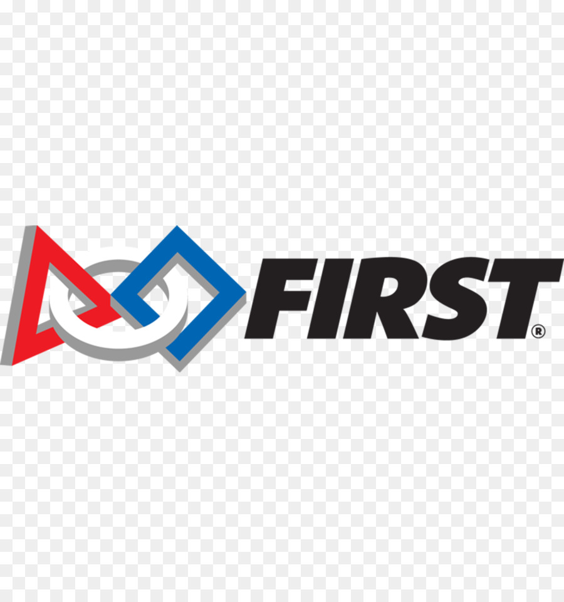
VOLUNTEER / OTHER WORK EXPERIENCE

Engineering Mentor - FIRST ROBOTICS (FRC), Kissimmee FL 1999 – Present
A Worldwide program where Engineers and Professionals mentor high school students to strategize, design, build & test a life-size robot in highly compressed timeframe (Volunteer)
- Lead Solidworks and Drivetrain Design seminars, organize tasks & work-teams, plan design strategy and lead field team, participate in Design Reviews & FMEA sessions with Disney Professional Engineers
• Demonstrated rapid prototyping techniques, & DC motor gearbox design for efficient & powerful robotic systems
• Focus on teaching design process, and creating quality, lasting, easily maintained product
• Certified Regional Robot Inspector, inspect for compliance with safety, design, and component usage rules

Organizing Lead - MAKERFAIRE ORLANDO, Orlando FL 2019 – Present
A Regional event to showcase innovation, technology, and everything else you can Make
• Oversee setup, operation, and teardown of venue involving over 100 vendors and exhibitors
• Skilled at conflict management, communication, and innovative problem solving

Operations Cast Member - WALT DISNEY WORLD PARK OPERATIONS, Lake Buena Vista, FL 2009-2013
• Trained operator of Omnimover system & associated ride & show control systems.
• Operate Automated Ticket System, collecting/comparing biometric scan data
Disney College Program / Representative
• Assemble comprehensive marketing plan to increase college program awareness to students and faculty at WSU, MSU, WCCC & Schoolcraft College.

